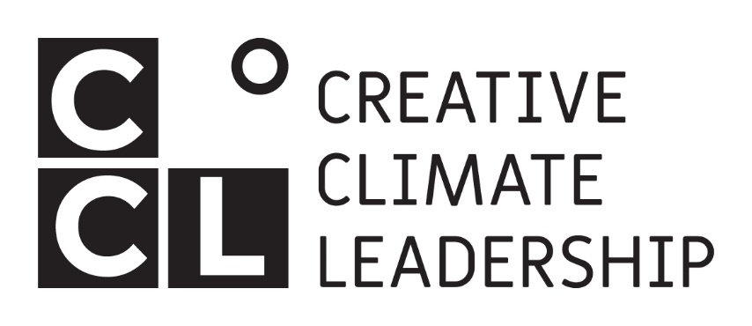

**Switzerland**

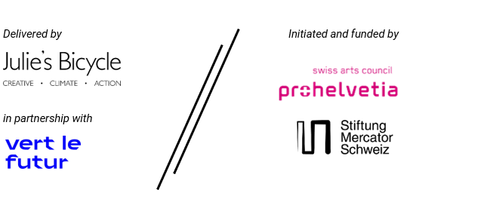

Creative Climate Leadership   
Application Form: Switzerland 2024

Your data will be kept securely and will not be shared with any third parties, and will only be seen by the application shortlisting panel (made up of employees of Julie’s Bicycle, Vert le Futur, Stiftung Mercator Schweiz and members of the Pro Helvetia expert jury pool) and observers (employees of Pro Helvetia). By submitting an application, you agree that the information you submit will be shared with the above. Personal data is not scored as part of the application process. Your contact details and any other information you submit will only be used to evaluate your application, and to contact you in connection with CCL Switzerland.

To submit your final application, please visit: <https://www.creativeclimateleadership.com/latest/applications-open-ccl-switzerland-2024/>

PLEASE NOTE: If you would prefer to submit a video application, please record a video of max 5 minutes addressing the questions in the application form, and send this as an **MP4 file via WeTransfer** to [cclswitzerland@juliesbicycle.com](mailto:cclswitzerland@juliesbicycle.com) with the subject line 'CCL Switzerland Video Application' along with your Personal Details. If you would like to discuss submitting an application in another format, please email [cclswitzerland@juliesbicycle.com](mailto:cclswitzerland@juliesbicycle.com).

Applicants agree they have read and understood the eligibility criteria provided in the call. **Please note**: **the programme will be delivered in English.**

|  |  |
| --- | --- |
| **Personal Details** |  |
| Full Name |  |
| Preferred Pronouns (e.g. She/Her, He/Him, They/Them) |  |
| Email Address |  |
| Nationality |  |
| Canton and City/Town you are applying from (please provide your full address if you are not a Swiss national) |  |
| Telephone number |  |
| Organisation Name / Independent |  |
| Your role |  |
| Artform(s) |  |
| Age | * 18 – 24 * 25 – 34 * 35 – 44 * 45 – 54 * 55 – 64 * 65 + * Prefer not to say |
| Do you need anything to support your participation, for example, any requirements you have related to a disability, or would you need any form of childcare support in order to be able to participate? |  |
| **Application Form** | |
| Please attach a CV of no more than 2 pages. *CVs may be provided in English, German, French or Italian.* |  |
| Short biography (500 characters max)  \**If you are accepted on the programme, this biography will be used in public communications. Please write it in third person.* |  |
| What does ‘creative climate leadership’ mean to you? What made you want to apply to this programme, and what would you like to get out of it? (1,500 characters max) |  |
| We want to reflect a variety of knowledge and experiences in the course and strive for a multitude of participants in terms of age, gender, sexual orientation, ethnicity, artistic expression, socio-economic background, geography, career level, and the kind of creative and cultural work you do.  From what perspective(s) would you like to explore "Creative Climate Leadership" and what are you hoping to bring to and learn from the group? (750 characters max) |  |
| How have you engaged with environmental themes or issues in your work to date? (1,000 characters max) |  |
| Describe what ‘climate justice’ means to you, and how your work addresses social justice, equity and/or inclusion. (1,000 characters max) |  |
| Share an example of when and how you have made an impact through your work. What happened, and what did you learn? (1,000 characters max) |  |
| Tell us about an idea you are either starting to develop, or have already developed and would like to build on, that connects culture and the environment. Please include what impact you'd like to achieve, who it is aimed at, your timeline, what challenges you are currently facing, and how you hope that CCL will support you to make it happen. (1,000 characters max) |  |
| Please share up to three links or documents to your work.  If you would like to share documents please do so via a link to a file sharing service, such Dropbox, GDrive or Box. |  |
| **Additional Information**  ***This question is not evaluated as part of the application. We have included it so applicants are aware of this expectation from the start, and to encourage you to think about any ideas at an early stage.*** | |
| As a part of this CCL, participants will be expected to contribute a session to the rest of the group. This can be as creative or practical or open as you like - for example an arts or crafts workshop, yoga or meditation, hosting a conversation on a theme that is close to your heart, sharing a personal story, an action-planning workshop, a challenge you’re grappling with, or a performance.  What would be a session you would like to contribute? (A more detailed brief will follow for successful applicants, and you'll have an opportunity to revise and refine your idea.) (500 characters max) |  |
| **Finances** |  |
| Participation in the programme is free, supported by Pro Helvetia and Stiftung Mercator Schweiz. This covers the costs of the programme, accommodation and food for the duration of your stay at Mattli Antoniushaus; and inclusion in an on-going network of CCL alumni including two post-course webinars.  Participants are expected to cover their own travel to and from the programme.  A limited number of stipends of up to CHF 2000 is available to support freelancers who would otherwise be unable to participate. | |
| Financial Support Applicants only: | |
| Can you confirm that you are self-employed and/or have not received the backing of an organisation to attend this programme? | ⬜ I confirm I am self-employed and/or have not received backing of an organisation to attend |
| Provide more detail about your request for financial support: |  |
| **And finally…** | |
| I would like to subscribe to the following newsletters:  ⬜ Julie’s Bicycle  ⬜ Vert le Futur  ⬜ Pro Helvetia  ⬜ Stiftung Mercator Schweiz | |

You will be notified of the outcome of your application by early January 2024.

**By submitting your application, in case your application is successful you agree to confirm your place, upload a headshot, and provide any additional info required within 5 working days of being notified.**

If you have any questions, please check the FAQs at [www.creativeclimateleadership.com](http://www.creativeclimateleadership.com) or contact us at cclswitzerland@juliesbicycle.com